**Website Files**

S3 bucket created:

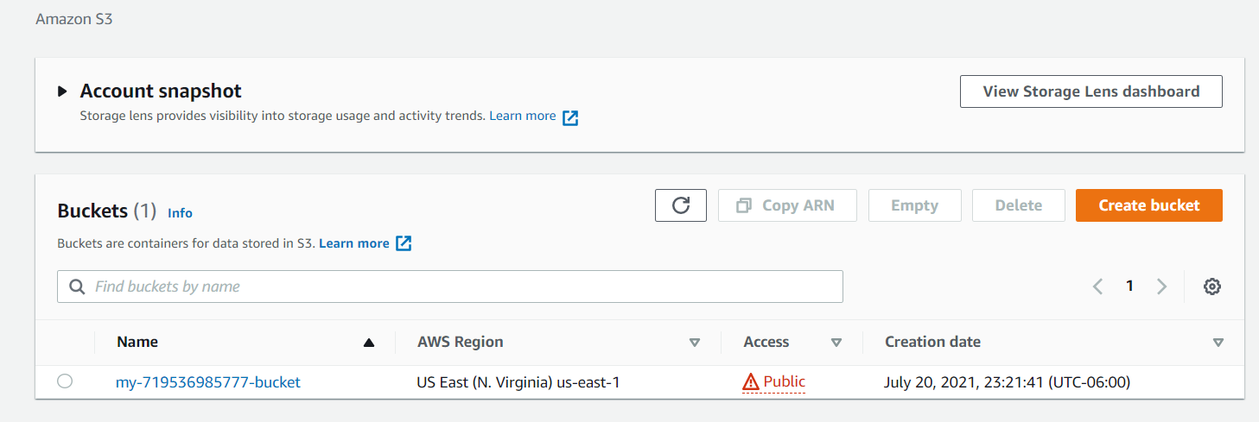

Files and folders uploaded to S3 Bucket:

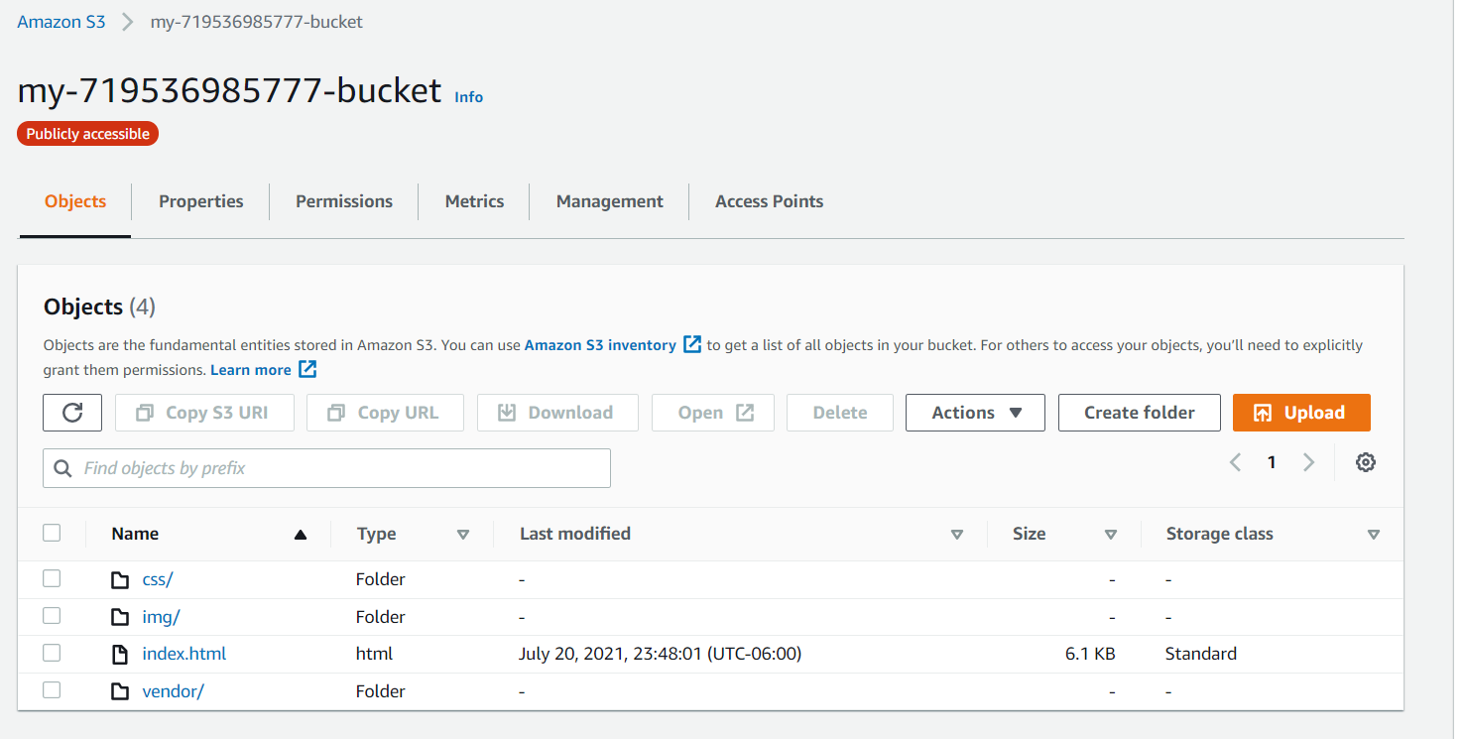

S3 bucket configured to support Static website:

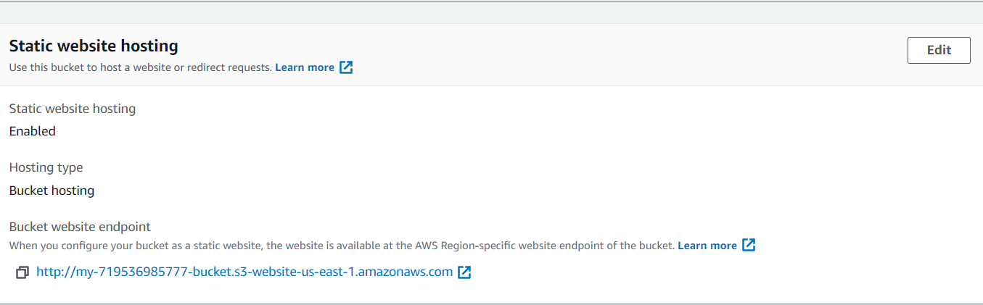

The S3 bucket IAM bucket policy that makes the bucket contents publicly accessible:

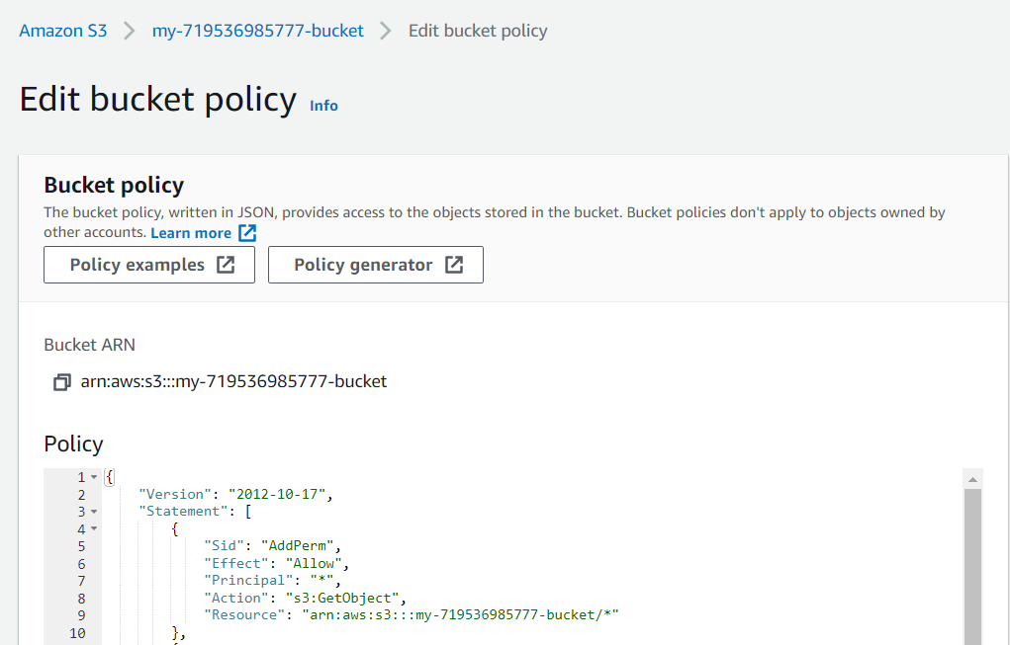

**Website Distribution**

CloudFront has been configured to retrieve and distribute website files:

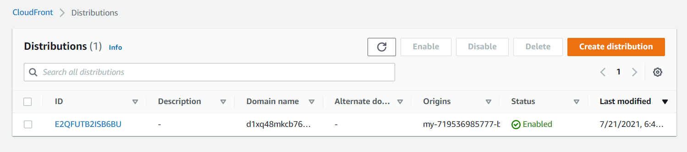

**Web Browser Access**

CloudFront endpoint URL: <https://d1xq48mkcb76xu.cloudfront.net>

Bucket website endpoint URL: <http://my-719536985777-bucket.s3-website-us-east-1.amazonaws.com>

S3 Object URL: <https://my-719536985777-bucket.s3.amazonaws.com/index.html>